Project Development Phase
Model Performance Test

Date | 19 February 2026
Team ID | LTVIP2026TMIDS66321
Project Name | Cafeteria Menu Display
Maximum Marks

Model Performance Testing:
Project team shall fill the following information in model performance testing template.
S.No. | Parameter | Values | Screenshot
 | Model Summary | 85.0%-95.0% (overall accuracy for combined features) | 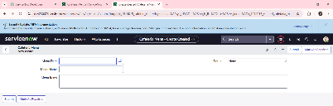
 | Accuracy | Training Accuracy – 90.31%  Validation Accuracy -90.0% | 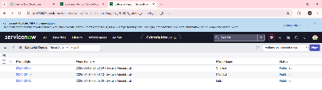
3. | Fine Tunning Result( if Done) | Validation Accuracy -89.6% | 